**Types of Supply Chain Management (SCM)**

**By Binoy Patra**

**📌 Introduction**

In today's complex and rapidly evolving business environment, Supply Chain Management (SCM) is no longer just an operational function — it's a strategic asset. Companies across industries are recognizing that a well-designed supply chain can be the difference between market leadership and falling behind. But with diverse products, markets, and customer expectations, there’s no one-size-fits-all approach to SCM.  
This document explores the **various types of SCM models**, categorized based on core operational and strategic factors such as **Inventory Management**, **Demand Management**, **Customer Involvement**, **Organizational Structure**, and **Business Strategy**. Additionally, we highlight advanced models like **Lean**, **Agile**, **Continuous Flow**, and **Fast Chain**, which have emerged as specialized strategies to meet dynamic market challenges.  
Each model is explained with practical examples, core principles, key practices, and when it is most effectively used in the industry. This guide is intended to offer clarity and serve as a reference for professionals, students, and businesses aiming to optimize or redesign their supply chain operations.

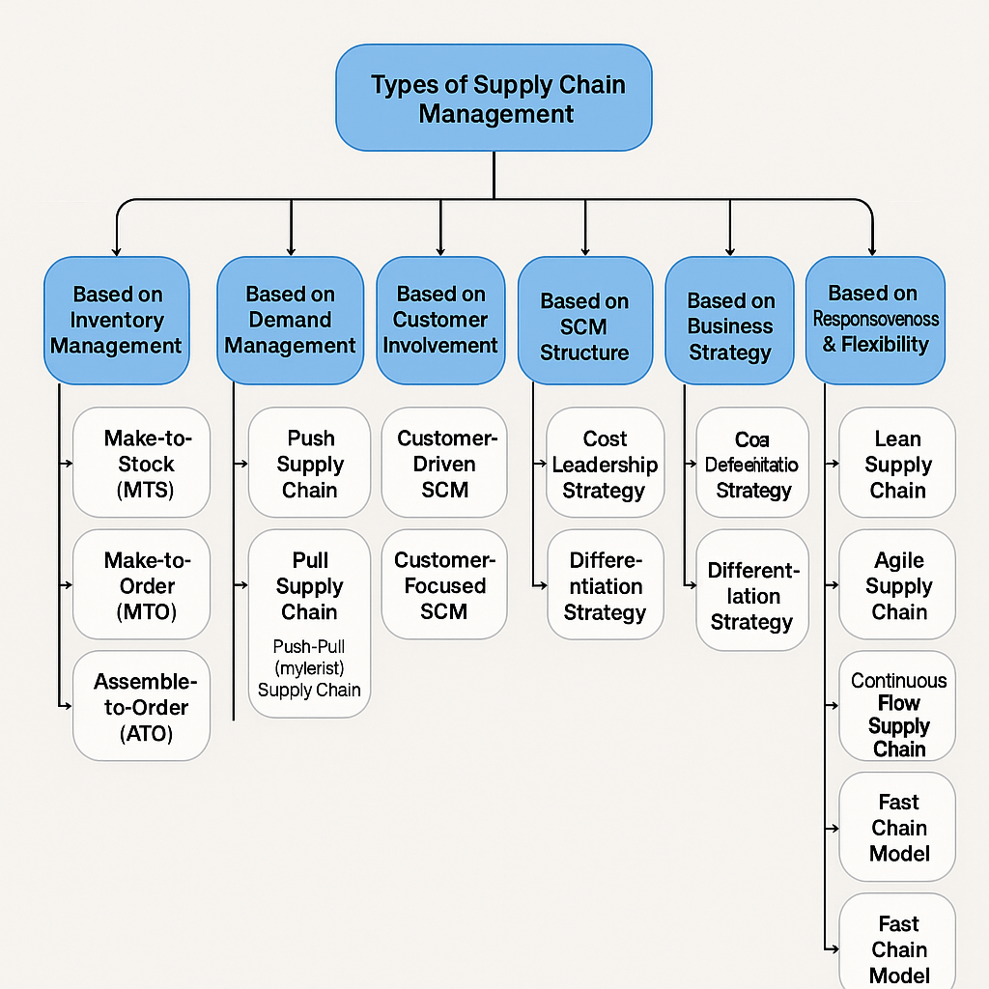

Fig: Types of SCM (Summary)

**1. SCM Based on Inventory Management**

Inventory management plays a crucial role in supply chain efficiency. Different types of SCM models depend on how inventory is managed to balance **demand**, **supply**, and **production capacity**. Based on this, we have the following types:

**a) Make-to-Stock (MTS)**

* **Core Idea**: This is a traditional inventory-based SCM strategy where companies produce goods based on anticipated demand and **stock inventory** for future sales.
* **Key Practices**:
  + Producing goods in **large batches** and storing them in warehouses.
  + Inventory forecasting is done based on historical sales data.
  + Keeping finished products available for immediate delivery.
* **Industry Focus**:
  + **Consumer Goods** (e.g., **Procter & Gamble**, **Coca-Cola**)
  + **Automotive** (e.g., **Ford**)
* **How it Works**: Products are produced in advance and stored in inventory, ready to be shipped when an order comes in. The company **pushes** products to the market based on demand forecasts.
* **When to Use**: This model is ideal when **demand is stable and predictable**, making it easier to forecast production and keep inventory stocked.

**b) Make-to-Order (MTO)**

* **Core Idea**: Products are manufactured only **after receiving customer orders**, meaning there is minimal or no inventory of finished goods.
* **Key Practices**:
  + Only producing items once a customer order is received.
  + **Inventory** is typically only raw materials and work-in-progress.
  + **Longer lead times** due to production after order placement.
* **Industry Focus**:
  + **Custom Manufacturing** (e.g., **Boeing** for airplanes)
  + **Furniture** (e.g., **IKEA** for customized home furniture)
* **How it Works**: Once an order is received, the company begins production, which can lead to longer delivery times.
* **When to Use**: Best used when **products are highly customizable** or **low-volume**, where it is not cost-effective to keep a finished product inventory.

**c) Assemble-to-Order (ATO)**

* **Core Idea**: Components or subassemblies are produced in advance and then **assembled into the final product** after receiving the customer order.
* **Key Practices**:
  + Pre-manufacturing the **components** and keeping them in inventory.
  + Final product assembly occurs once the order is placed.
  + Faster delivery than MTO because components are pre-assembled.
* **Industry Focus**:
  + **Computer Systems** (e.g., **Dell** for custom-built computers)
  + **Automobiles** (e.g., **BMW** for custom car features)
* **How it Works**: The company keeps inventory of standard parts, and the final product is configured to the customer’s preferences.
* **When to Use**: This model is ideal when customers want **customization** but the components are standard.

**2. SCM Based on Demand Management**

Demand management plays a pivotal role in how products are planned, produced, and distributed. It involves managing customer expectations, forecasting demand, and aligning supply accordingly. Based on demand management, the types of SCM can be categorized as follows:

**a) Push Supply Chain**

* **Core Idea**: The **Push Supply Chain** is driven by demand forecasts. Products are produced or ordered in advance based on expected customer demand.
* **Key Practices**:
  + **Forecasting** demand for products and pushing inventory into the supply chain.
  + **Stocking** products ahead of time based on predicted sales.
  + High reliance on sales predictions and trends.
* **Industry Focus**:
  + **Electronics** (e.g., **Apple**, **Samsung**)
  + **Retail** (e.g., **Walmart**)
* **How it Works**: Based on forecasted demand, production and inventory decisions are made. Products are manufactured and pushed into distribution channels.
* **When to Use**: Best used when **demand is relatively predictable**, and products have **long shelf-lives** or steady market demand.

**b) Pull Supply Chain**

* **Core Idea**: The **Pull Supply Chain** is based on actual customer demand. Production and inventory management are driven by orders placed by customers.
* **Key Practices**:
  + **Customer orders drive production**; production only starts when there’s actual demand.
  + Minimal inventory is kept, and production is flexible.
  + Products are only manufactured when required, reducing excess stock.
* **Industry Focus**:
  + **Fashion** (e.g., **Zara**)
  + **Tech Industry** (e.g., **Dell** for made-to-order PCs)
* **How it Works**: Companies **respond to customer orders** rather than pushing inventory based on forecasts. This allows companies to quickly adapt to **changing customer preferences** and reduce excess inventory.
* **When to Use**: Best used in industries where **demand is volatile** or products are **customized**. This model ensures high **flexibility** and minimizes inventory costs.

**c) Push-Pull Supply Chain (Hybrid Model)**

* **Core Idea**: The **Push-Pull** model combines both push and pull strategies to balance the benefits of both. The early part of the supply chain follows a **push strategy** (forecast-based), while the final stages are managed using a **pull strategy** (order-based).
* **Key Practices**:
  + Forecasting demand early in the production process but **customizing production** based on actual customer orders in the later stages.
  + Use of both **finished goods inventory** and **customized production**.
* **Industry Focus**:
  + **Retail and E-commerce** (e.g., **Amazon**, **Nike**)
  + **Automobile Manufacturing** (e.g., **Ford**, **GM**)
* **How it Works**: Companies produce products based on demand forecasts but allow for **customization and flexibility** toward the end of the supply chain, based on actual customer orders.
* **When to Use**: Best for industries with **variable demand**, where parts of the product are standardized, but other elements require customization, such as **personalized products**.

**3. SCM Based on Customer Involvement**

Customer involvement is a critical factor in how supply chains are designed and managed. Depending on the degree of customer interaction, SCM models can be classified as follows:

**a) Customer-Driven SCM**

* **Core Idea**: In this model, the customer has significant input throughout the supply chain. The supply chain adapts based on real-time customer demands, preferences, and feedback.
* **Key Practices**:
  + **Real-time order tracking**.
  + Customization options are provided to the customer.
  + **High level of interaction** with customers to gather insights and influence production and delivery.
* **Industry Focus**:
  + **E-commerce** (e.g., **Amazon**, **Alibaba**)
  + **Tech Industry** (e.g., **Apple** for product customizations)
* **How it Works**: Customers actively participate in the design, development, and delivery processes. For instance, in e-commerce, customers can track products in real-time, personalize their orders, and even influence delivery methods.
* **When to Use**: Ideal for **industries where customer preferences are highly dynamic**, such as **personalized products**, or in industries like **fashion** and **electronics** where customization is a strong selling point.

**b) Customer-Focused SCM**

* **Core Idea**: While customers influence the supply chain, the focus is more on meeting general customer needs rather than allowing direct interaction in the process. This model balances customer demand with operational efficiency.
* **Key Practices**:
  + Forecasting general demand based on customer behavior and trends.
  + Offering **limited customization options** while maintaining overall efficiency in production and delivery.
  + **Responsive delivery systems** based on customer expectations.
* **Industry Focus**:
  + **Retail** (e.g., **Walmart**, **Target**)
  + **Consumer Goods** (e.g., **Nestlé**)
* **How it Works**: The supply chain is designed to **meet expected customer needs** efficiently. For example, inventory is stocked in anticipation of demand, but customers do not have the same level of direct influence over product customization.
* **When to Use**: Best used for **mass-market products** where customization is not as critical, but customer expectations around **speed and availability** are high.

**4. SCM Structure: Centralized vs. Decentralized**

The structure of a supply chain determines how decisions are made, how information flows, and how resources are allocated. SCM can be broadly classified into two structures: **Centralized** and **Decentralized**.

**a) Centralized SCM**

* **Core Idea**: A centralized SCM structure involves decision-making and resource management happening at a **central point**, often at the headquarters or a central hub.
* **Key Practices**:
  + Decision-making is centralized, allowing for **consistency and uniformity** in operations.
  + Centralized inventory and logistics management.
  + Focus on **cost reduction** and **standardization**.
* **Industry Focus**:
  + **Multinational Corporations** (e.g., **Coca-Cola**, **Unilever**)
  + **Retail Chains** (e.g., **Best Buy**, **Home Depot**)
* **How it Works**: All major decisions, such as inventory procurement, production planning, and distribution, are made at a central level. This structure is efficient for handling global operations but may lack responsiveness to local market needs.
* **When to Use**: Best suited for businesses that want to achieve **consistency**, **control**, and **cost-efficiency** across multiple locations.

**b) Decentralized SCM**

* **Core Idea**: In a decentralized structure, decision-making and resources are spread across multiple locations or business units, allowing for **flexibility** and **local responsiveness**.
* **Key Practices**:
  + Local managers or business units handle decisions related to inventory, production, and logistics.
  + **Higher responsiveness** to regional demand.
  + More **autonomy** for different divisions or geographical locations.
* **Industry Focus**:
  + **Franchise Operations** (e.g., **McDonald’s**, **Subway**)
  + **Technology Companies** (e.g., **Microsoft** with global offices)
* **How it Works**: Local branches or regions are given the authority to make supply chain decisions that are best suited to their market needs. For example, a regional branch of a company may be able to source raw materials locally to reduce costs.
* **When to Use**: Ideal for companies that operate in **multiple geographical regions** where **local market dynamics** need to be addressed quickly and effectively.

**5. SCM Strategy: Cost Leadership vs. Differentiation**

Supply chain strategy can significantly influence how a business competes in the market. Depending on the company's overall business strategy, its SCM can either be optimized for **cost leadership** or **differentiation**.

**a) Cost Leadership Strategy**

* **Core Idea**: The primary focus is on minimizing costs to offer the lowest possible price to customers, often achieved through efficient supply chain practices.
* **Key Practices**:
  + Emphasis on reducing production, procurement, and distribution costs.
  + **Lean inventory management** and streamlined operations.
  + Focusing on **economies of scale** to drive down costs.
* **Industry Focus**:
  + **Retail** (e.g., **Walmart**)
  + **Fast-Moving Consumer Goods (FMCG)** (e.g., **Unilever**)
* **How it Works**: The supply chain is designed to deliver maximum efficiency at the lowest cost. Products are sourced from low-cost suppliers, and distribution networks are optimized to minimize expenses.
* **When to Use**: Best for companies looking to **dominate the market with low prices** and operate in industries where customers are highly price-sensitive.

**b) Differentiation Strategy**

* **Core Idea**: The supply chain is focused on creating value through unique offerings, such as **high-quality products**, **customization**, or **superior customer service**.
* **Key Practices**:
  + Use of **advanced technology** for customization and innovation.
  + High focus on **quality control** and **customer service**.
  + **Responsive supply chain** to adapt to changing customer preferences.
* **Industry Focus**:
  + **Luxury Goods** (e.g., **Rolex**)
  + **Technology** (e.g., **Apple**)
* **How it Works**: The supply chain prioritizes customer value over cost savings, offering high-quality, differentiated products. For example, a company may offer **customization options** in its products, which requires a flexible supply chain.
* **When to Use**: Ideal for companies that want to differentiate their product offering based on **quality**, **service**, or **uniqueness** rather than price.

**6. SCM Based on Operating Model**

These models focus on how the supply chain reacts to **market conditions**, **customer needs**, and **business goals**. They're especially important in today's fast-moving environments like fashion, tech, and consumer goods.

**a. Lean Supply Chain**

* **Core Idea**: Minimize waste, maximize efficiency.
* **Key Practices**:
  + Just-in-time (JIT) inventory
  + Streamlined processes
  + Continuous improvement (Kaizen)
* **Industry Focus**:
  + Automotive (e.g., Toyota)
  + Manufacturing with stable demand
* **How It Works**: The supply chain is tightly controlled to reduce excess inventory, overproduction, and downtime.
* **When to Use**: Best when **demand is predictable**, and cost efficiency is the top priority.

**b. Agile Supply Chain**

* **Core Idea**: Be highly flexible and responsive to change.
* **Key Practices**:
  + Real-time data usage
  + Modular production systems
  + Quick changeovers in operations
* **Industry Focus**:
  + Fashion (e.g., Zara)
  + Tech and Electronics (e.g., Apple during launches)
* **How It Works**: Agility allows businesses to quickly adapt to trends, disruptions, and customer needs.
* **When to Use**: Ideal for industries with **volatile demand**, **short product life cycles**, or high **customer customization**.

**c. Continuous-Flow Supply Chain**

* **Core Idea**: Ensure a steady, uninterrupted flow of products.
* **Key Practices**:
  + Fixed production schedules
  + Standardized products
  + High-capacity utilization
* **Industry Focus**:
  + FMCG (e.g., Nestlé, Unilever)
  + Pharmaceuticals
* **How It Works**: Goods flow continuously through the supply chain — from suppliers to production to retail — based on consistent demand.
* **When to Use**: Works well for **high-volume, low-variability products** where demand is stable and speed matters.

**d. Fast Chain Model**

* **Core Idea**: Speed is everything — respond quickly to market trends.
* **Key Practices**:
  + Rapid product development
  + Frequent restocking
  + Use of real-time sales data
* **Industry Focus**:
  + Fast Fashion (e.g., H&M)
  + Consumer Electronics (e.g., smartphone accessories)
* **How It Works**: Prioritizes getting products to market as fast as possible, often sacrificing customization for speed.
* **When to Use**: Perfect for industries where **product life cycles are short**, and **market trends change quickly**.

**✅ Conclusion**

Supply Chain Management is a dynamic discipline, deeply influenced by technology, consumer behaviour, globalization, and environmental considerations. The wide range of SCM types — from inventory-based models like **Make-to-Stock** to strategic frameworks like **Agile** or **Lean** — allows businesses to choose an approach that best fits their goals, products, and customers.  
By understanding these models through the lenses of **strategy**, **customer involvement**, **demand**, and **structure**, organizations can build more **resilient, efficient, and customer-focused supply chains**.  
Whether aiming for **cost efficiency**, **speed**, **quality**, or **flexibility**, selecting the right SCM model is crucial to ensuring long-term business success in an ever-changing global marketplace.